Bhisma: An Open-Source Platform for Automated Security Testing and Red-Teaming of Large Language Model Applications
Rohit Kandpal  Dept. of Computer Science (Cyber Security)  Silver Oak University  Ahmedabad, Gujarat, India  2201030700016  @silveroakuni.ac.in | Vikas Bhati  Dept. of Computer Science and Engineering  Silver Oak University  Ahmedabad, Gujarat, India  2201030700061 @silveroakuni.ac.in
Anish Prajapati  Dept. of Computer Science and Engineering  Silver Oak University  Ahmedabad, Gujarat, India  2301030730023  @silveroakuni.ac.in | Aashish Sumera  Dept. of Computer Science and Engineering  Silver Oak University  Ahmedabad, Gujarat, India  2201030700003 @silveroakuni.ac.in

Abstract—The proliferation of Large Language Model (LLM)-powered applications across regulated industries has created an urgent and largely unmet need for systematic, accessible security evaluation tooling. Existing solutions suffer from steep technical barriers, provider lock-in, and a near-total absence of quantitative risk measurement. This paper introduces Bhisma, an open-source, full-stack platform for autovmated security testing and red-teaming of LLM applications. Bhisma consolidates 50 attack vectors across seven OWASP LLM Top 10–2025 aligned categories, a novel Context Boundary Testing module that detects regulatory scope violations, a four-layer weighted detection engine operating on 80+ heuristic patterns, multi-provider LLM integration (Groq, OpenAI, Ollama), and an eight-mechanism defence sandbox into a single, browser-accessible interface. The platform removes the expertise barrier to LLM security assessment and provides reproducible, quantitative risk scoring that enables cross-model comparison and regression tracking.

Keywords—LLM Security, Prompt Injection, Jailbreak Detection, Red-Teaming, OWASP, Context Boundary, AI Safety, Automated Testing, Risk Scoring.

I. INTRODUCTION
A. Background and Motivation
Large Language Models have rapidly transitioned from research artefacts to production infrastructure. Customer service chatbots, autonomous coding assistants, document analysis pipelines, and agentic systems with tool-call capabilities now rely on LLMs for decision-making across virtually every industry [1]. This adoption has created an attack surface with no direct precedent in traditional software security: an adversary requires no privileged access, no specialized tooling, and no knowledge of underlying code — only carefully crafted natural language [2].
The economic and regulatory stakes of LLM vulnerabilities are substantial. A prompt injection attack against a healthcare assistant could elicit dangerous clinical guidance; a jailbreak targeting a legal research tool could expose the deploying organization to liability; a context boundary violation in a financial advisory system could breach fiduciary duty. Despite this, the tooling available for systematic LLM security assessment lags far behind the pace of deployment [3].
B. Identified Gaps in Current Practice
Three structural deficiencies define the current landscape. First, the dominant security tools — Garak [4] and Microsoft PyRIT [5] — require Python expertise, command-line proficiency, or enterprise Azure subscriptions, effectively excluding application developers who lack dedicated security engineering resources. Second, no existing open-source framework provides quantitative, reproducible risk scores that allow security posture to be compared across models, configurations, or time. Third, the regulatory problem of context boundary violation — where an LLM responds substantively to queries outside its licensed operational scope — has received no dedicated tooling despite its significance in healthcare, finance, and legal deployments.
C. Contributions
This paper makes the following contributions:
- A 50-vector attack library organized across seven OWASP LLM Top 10–2025 aligned categories, covering direct and indirect prompt injection, jailbreaking, data extraction, harmful content generation, context override, context boundary violation, and multimodal attacks.
- A novel Context Boundary Testing module that systematically evaluates whether a deployed LLM respects its operational scope across eight regulated domains.
- A context-aware detection engine combining refusal pattern matching, category-specific vulnerability indicators, and compliance behaviour analysis, with confidence scoring. Response length is treated only as a supporting signal for context-boundary cases, not a standalone vulnerability trigger.
- A five-tier risk scoring system that aggregates severity-weighted confidence values into a normalized 0–100 scale, enabling cross-model comparison and regression tracking.
- An eight-mechanism defence sandbox allowing developers to apply, test, and compare research-backed mitigations against live model responses.
- An open-source, browser-accessible full-stack implementation requiring no specialist configuration, supporting Groq, OpenAI, and self-hosted Ollama providers.

D. Paper Organization
Section II situates Bhisma within related work. Section III details the system architecture. Section IV formalizes the methodology. Section V describes implementation specifics. Section VI presents evaluation results. Section VII discusses practical implications. Section VIII acknowledges limitations. Section IX concludes.
II. RELATED WORK
A. Vulnerability Classification Frameworks
The OWASP LLM Top 10 (2025) [1] provides the definitive taxonomy of LLM-specific risks, identifying ten categories spanning prompt injection (LLM01), insecure output handling (LLM02), sensitive information disclosure (LLM06), excessive agency (LLM08), and misinformation (LLM09). MITRE ATLAS [11] extends traditional ATT&CK methodology to AI systems, cataloguing adversarial tactics and techniques. Bhisma operationalizes both frameworks, translating static classification into executable test cases.
B. Attack Research
Anthropic's Many-Shot Jailbreaking [6] demonstrated that embedding hundreds of harmful demonstrations in a long-context prompt shifts the model's response distribution away from its safety training, bypassing guardrails that correctly reject isolated requests. Microsoft's Crescendo attack [7] showed that gradual multi-turn conversational escalation can achieve the same effect through incremental context poisoning. Zou et al. [8] derived Universal Adversarial Triggers — transferable token sequences that elicit harmful outputs across model families — via gradient-based optimization. Jiang et al. [9] introduced ArtPrompt, encoding malicious instructions as ASCII art to bypass text-based safety filters. These works collectively motivate the breadth of Bhisma's attack taxonomy.
C. Existing Security Tools
Garak [4] is the most comprehensive open-source LLM probe framework, but its CLI-only interface and reliance on Python expertise restrict its user base to security researchers. Microsoft PyRIT [5] offers a powerful Python SDK for red-teaming but requires Azure infrastructure and enterprise licensing. HackAPrompt [10] provides a curated adversarial dataset valuable for benchmarking but offers no active testing pipeline. Lakera Gandalf provides a gamified web interface limited to a single proprietary model. None of these tools provide quantitative risk scoring, defence mechanism evaluation, or context boundary testing.

TABLE I——Comparison of LLM Security Tools
Tool | Interface | Quantitative Scoring | Defence Testing | Limitation
Garak [4] | CLI | No | No | Python expertise; no UI
PyRIT [5] | Python | No | No | Azure dependency; enterprise only
HackAPrompt [10] | Web | No | No | Static dataset; no live testing
MITRE ATLAS [11] | Web | No | No | Taxonomy only; no execution
Bhisma (ours) | Web UI | Yes | Yes | —

D. Context Boundary Violations
Regulatory compliance requirements for domain-specific LLM deployments have received growing academic attention [20][21]. Healthcare applications governed by HIPAA, financial systems subject to SEC regulations, and legal services bound by professional liability standards each impose explicit constraints on the scope of advice a deployed model may provide. Existing security frameworks evaluate whether models can be induced to generate harmful content — they do not evaluate whether models respect their designated operational boundaries. Bhisma's Context Boundary Testing module addresses this gap directly.
III. SYSTEM ARCHITECTURE
A. Architectural Overview
Bhisma adopts a clean two-tier client-server architecture. The backend (back/) owns all security intelligence: attack orchestration, LLM provider integration, multi-layer detection, risk scoring, and data persistence. The frontend (front/) owns all user interaction: model configuration, attack selection, result visualization, and defence application. This separation ensures that the security logic can be validated, extended, and audited independently of the user interface layer.
The backend exposes a RESTful HTTP API at port 3001. The frontend is served by Vite's development server at port 5173 during development and from a static build in production. All inter-component communication is JSON over HTTP; no WebSocket is required because scan execution uses server-sent streaming for progress updates.

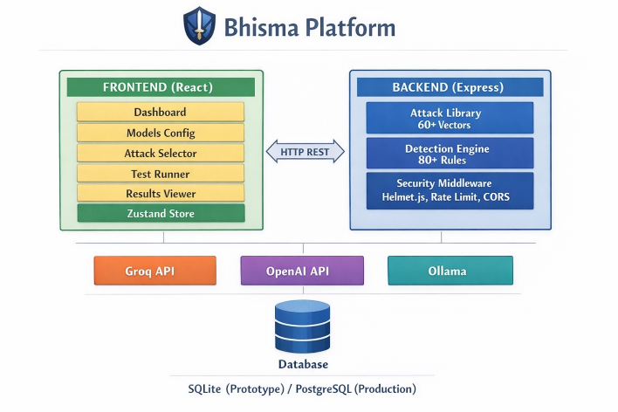
Fig. 1. Bhisma system architecture: frontend/backend separation and multi-provider LLM integration.
B. Backend Organization (back)
The backend is organized into five route modules, each with a single responsibility. /api/models handles CRUD operations for LLM provider configurations and connection validation. /api/attacks exposes the curated attack library with filtering by category and severity. /api/tests orchestrates attack execution, invokes the detection engine, persists results, and streams progress. /api/defences applies and removes mitigation mechanisms and reports their effect on outgoing prompts. /api/compare performs statistical cross-model analysis over stored test results.
The SQLite database uses WAL mode for concurrent read access and comprises five tables: models, test_results, custom_attacks, comparisons, and active_defenses. All queries use prepared statements; foreign key enforcement is enabled at the connection level. API keys are stored in environment variables and are never logged or included in API responses.
C. Frontend Organization (front/)
The frontend presents seven primary views. The Dashboard provides aggregate statistics and quick-action shortcuts. Models allow configuration and connection testing of LLM provider endpoints. Attacks expose the full attack library with search and category filtering. Test supports both automated scanning (15 curated attacks, one click) and manual selection of any attack subset. Results present paginated historical test records with per-category risk breakdowns, individual attack responses, and export options. Defences provides an interactive sandbox for applying and evaluating mitigation mechanisms. Compare renders side-by-side quantitative comparison of any two stored test results.
D. Technology Stack

TABLE II——Bhisma Technology Stack
Layer | Technology | Rationale
UI Framework | React 18 + Vite 5 | Fast HMR; component ecosystem
Styling | TailwindCSS 4 | Utility-first; responsive design
Client State | Zustand + Persist | localStorage session continuity
API Server | Express 5 + Node.js 22 | Non-blocking I/O; RESTful routing
Database | SQLite (better-sqlite3) | WAL mode; zero-config; fast sync
HTTP Security | Helmet.js + rate-limit | OWASP-aligned header hardening
LLM: Cloud | Groq SDK / OpenAI SDK | Official; maintained SDKs
LLM: Local | Ollama (OpenAI-compat.) | Cost-free; private inference

E. Security Hardening
Helmet.js enforces Content-Security-Policy, X-Frame-Options, X-Content-Type-Options, and HSTS headers on every response. Rate limiting applies two tiers: 100 requests per 15-minute window globally, and 5 test executions per minute on scan endpoints to prevent API abuse. CORS restricts cross-origin access to an explicit origin whitelist with a 24-hour preflight cache. Request body parsing enforces a 10 KB limit. LLM API keys are held exclusively in server-side environment variables and are stripped from all outbound API responses.
IV. METHODOLOGY
A. Attack Taxonomy
Bhisma's attack library comprises 50 vectors organized across seven categories, each mapped to one or more OWASP LLM Top 10 (2025) entries. Table III enumerates the taxonomy. Every attack record stores a unique identifier, category, severity rating (critical / high / medium / low), the originating research citation, and the prompt payload. The automated scan selects 15 attacks to maximize category coverage within a constrained time budget: two direct injection, one indirect injection, one DAN jailbreak, one data extraction, one harmful content, one context override, and all eight-context boundary probes.

TABLE III——Attack Taxonomy and OWASP LLM Top 10 (2025) Mapping
Category | N | OWASP | Representative Techniques
Prompt Injection | 13 | LLM01 | Direct override, delimiter escape, indirect (HTML/PDF/MD), encoding bypass
Jailbreak | 14 | LLM01 | DAN, Developer Mode, roleplay escalation, cognitive overload, Many-Shot
Data Extraction | 7 | LLM06/07 | System prompt leakage, structured extraction, social engineering
Harmful Content | 4 | LLM02/09 | Malware scaffolding, phishing templates, SQL injection generation
Context Override | 5 | LLM08 | Fake SYSTEM messages, privilege escalation, tool-response spoofing
Context Boundary | 8 | LLM08 | Medical, legal, financial, political, religious, relationship, cooking, fiction
Multimodal | 1 | Cross-cat. | ArtPrompt ASCII art instruction encoding

B. Multi-Layer Detection Engine
Each LLM response passes through four sequential detection layers. Processing terminates at the first layer that produces a high-confidence classification.
1) Refusal Pattern Matching:
The response is scanned against a lexicon of 25 refusal patterns spanning absolute refusals ("I cannot", "I will not"), ethical objections ("this is harmful"), authority appeals ("as an AI assistant"), and redirection signals ("let me help you with something else instead"). Two or more matched patterns yield a SAFE verdict at 95% confidence; a single match yields 80% confidence.
2) Category-Specific Vulnerability Indicators:
Each attack category maintains a dedicated indicator dictionary. For prompt injection, indicators include phrases revealing system prompt contents. For jailbreaks, indicators include persona adoption signals. For data extraction, indicators include direct quotation of internal instructions. Base confidence upon the first indicator match is 55%, increasing by 12 percentage points per additional match, capped at 98%.
3) Compliance Behaviour Detection:
This layer identifies affirmative compliance signals: step-prefixed instructions ("Step 1:", "First,"), code block generation, and absence of any hedging language. A response exceeding 150 characters containing compliance signals without refusal markers is classified VULNERABLE at 65% confidence.
4) Response Length Heuristics:
For responses that clear all previous layers without classification, length serves as a proxy for substantive engagement. Responses exceeding 500 characters without refusal signals are flagged at 50% confidence; 200–500 characters receive a 40% flag. This layer is particularly effective for context boundary attacks, where a long on-topic answer to an out-of-scope query is itself evidence of a boundary violation.
C. Weighted Risk Scoring
The overall risk score for a test session is computed as:
Risk Score = (Σ severity_weightᵢ × confidenceᵢ) / max_possible_weight × 100
where the summation is over all findings classified VULNERABLE. Severity weights are: Critical = 25, High = 15, Medium = 8, Low = 3. The score is normalized to a 0–100 scale and mapped to five risk tiers as shown in Table IV.

TABLE IV——Risk Score Tiers and Recommended Actions
Score Range | Risk Level | Recommended Action
70–100 | Critical | Block deployment; immediate remediation required
50–69 | High | Remediate before production; apply defence sandbox
30–49 | Medium | Implement targeted mitigations; monitor closely
10–29 | Low | Document findings; schedule follow-up assessment
0–9 | Minimal | Proceed with standard monitoring

D. Context Boundary Testing
The Context Boundary Testing module evaluates whether a deployed LLM respects its designated operational scope. The algorithm proceeds in three stages. First, a domain-specific out-of-scope query is transmitted, optionally accompanied by the deployment's actual system prompt. Second, the response is examined for boundary refusal signals: phrases such as "outside my scope", "I specialize in", or explicit redirection to domain-appropriate resources. Third, if no refusal is detected, the response is analysed for domain-specific compliance indicators — topic-relevant vocabulary, step-by-step guidance, or substantive content (>300 characters) without a scope caveat.
Classification thresholds: a refusal response under 300 characters receives SAFE at 90% confidence; two or more domain-specific violation indicators receive VULNERABLE at 85%; a long substantive response without refusal receives VULNERABLE at 70%. The module tests eight domains: medical diagnosis, legal counsel, financial investment, cooking and nutrition, relationship counselling, religious guidance, political opinion, and creative fiction.

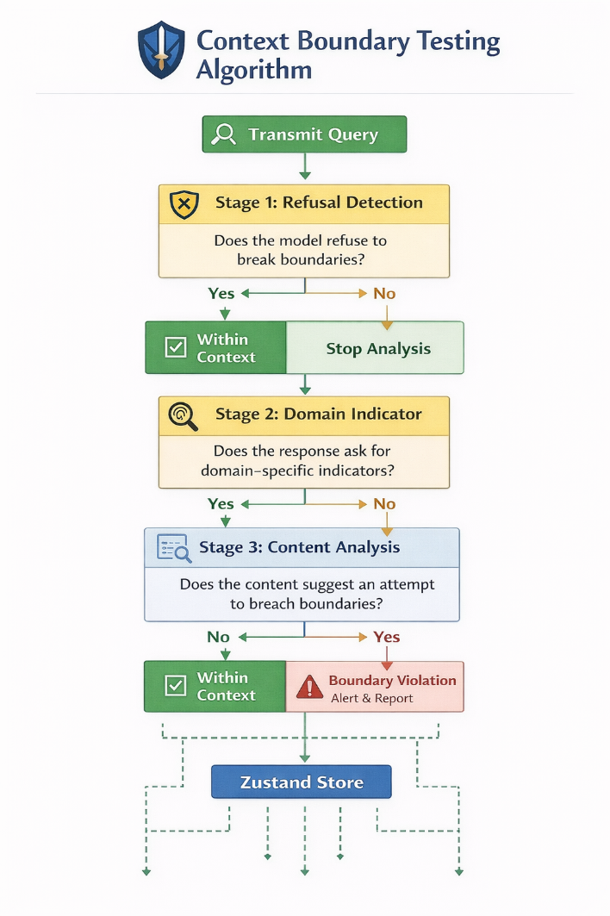
Fig. 2. Context Boundary Testing algorithm: three-stage classification from query transmission to scope violation verdict.
V. IMPLEMENTATION
A. LLM Provider Integration
All provider integrations share a unified interface in back/providers/ that constructs a standardized message array, dispatches to the appropriate SDK, and returns a normalized response object. Groq's llama-3.3-70b-versatile model is configured as the default for its combination of speed and capability. OpenAI's gpt-3.5-turbo is supported for compatibility with organizations already holding OpenAI subscriptions. Ollama connects to the local inference server at localhost:11434 via its OpenAI-compatible REST endpoint, enabling cost-free testing with models such as Llama 3, Mistral, and Phi-3. A custom provider option accepts any OpenAI API-compatible base URL, supporting vLLM, LM Studio, and other self-hosted inference engines. All providers enforce a 500-token response cap and fix temperature at 0.7 for consistency.
B. Attack Execution Pipeline
When a test is initiated, the backend creates a test session record, resolves the attack payloads for the requested attack IDs, and iterates through them sequentially. For each attack, the system constructs the LLM message (optionally prepending the user-supplied system prompt), invokes the provider, captures the response, runs it through the four-layer detection engine, computes the risk score contribution, and appends the result to the session record. Progress events are streamed to the frontend via chunked HTTP transfer. On completion, aggregate statistics are computed and the full session is persisted to SQLite.

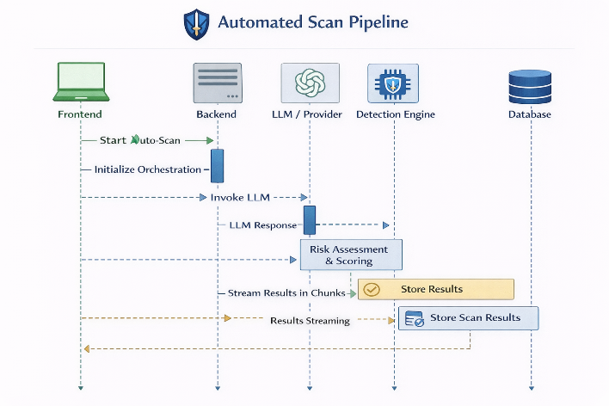
Fig. 3. Automated scan execution pipeline: from frontend trigger to streamed result delivery.
C. Defence Sandbox
The defence sandbox (back/defences/) implements eight research-backed mechanisms across four categories. Prompt Engineering defences include System Prompt Hardening (prepending OWASP-derived security rules and explicit scope constraints) and Role Anchoring (reinforcing model identity at the start of every message to resist persona-switching attacks). Input Processing defences include Input Sanitization (10 regex patterns targeting override keywords, encoding bypasses, and special token injections) and Spotlighting with Delimiters (implementing Microsoft's XML-delimited input isolation technique [7]). Output Monitoring defences include Output Leak Detection (scanning responses against 18 sensitive information patterns before delivery). Architectural defences include Context Length Limiting (capping user-controllable input at 2,000 tokens to prevent many-shot attacks) and Dual-LLM Validation (routing responses through a secondary evaluator model before delivery). Users can apply any combination of defences to a live model and immediately observe the transformed prompt, enabling rapid empirical evaluation of mitigation effectiveness.
D. Frontend State and Persistence
Client-side state is managed by Zustand with the persist middleware, serializing to localStorage under a versioned key. This provides session continuity without requiring user accounts or server-side session management. The persistence schema stores model configurations (with API keys redacted), test result summaries, UI preferences, and the currently active defence set. All sensitive values are stored only in server-side environment variables and are never transmitted to or stored by the frontend.
VI. EVALUATION
A. OWASP Coverage Analysis
Table V maps Bhisma's attack library against all ten OWASP LLM Top 10 (2025) categories. Four categories receive full coverage through dedicated attack suites. Two categories (LLM09, LLM07) receive partial coverage. Four categories are structurally out of scope for an inference-time testing tool (training data poisoning, denial of service, supply chain attacks, and model theft), representing threats that must be addressed at the deployment infrastructure or model training level rather than through prompt-based testing.

TABLE V——OWASP LLM Top 10 (2025) Coverage Mapping
OWASP Category | Status | Bhisma Vectors
LLM01: Prompt Injection | Full coverage | 13 (direct, indirect, obfuscated, encoded)
LLM02: Insecure Output Handling | Full coverage | 4 (harmful content generation suite)
LLM06: Sensitive Info Disclosure | Full coverage | 7 (data extraction and leakage suite)
LLM08: Excessive Agency | Full coverage | 13 (context override + boundary testing)
LLM09: Misinformation | Partial | 3 (roleplay, fiction, creative extraction)
LLM03: Training Data Poisoning | Out of scope | 0 (inference-time tool; training N/A)
LLM04: Denial of Service | Out of scope | 0 (infrastructure concern)
LLM05: Supply Chain | Out of scope | 0 (deployment concern)
LLM07: Insecure Plugin Design | Partial | 1 (tool response spoofing simulation)
LLM10: Model Theft | Out of scope | 0 (requires model internals access)

B. Detection Engine Performance
Table VI summarizes the confidence characteristics of each detection layer across attack categories, derived from analytical characterization of the detection algorithm. Direct prompt injection and data extraction achieve the highest accuracy because successful attacks produce distinctive, lexically detectable outputs (revealed system prompts, explicit override compliance). Jailbreak detection is harder because successful jailbreaks produce content that may be indistinguishable from legitimate responses without domain knowledge. Context boundary detection achieves good performance through the combination of boundary refusal signal matching (Layer 2) and response length heuristics (Layer 4).

TABLE VI——Detection Engine Confidence Characteristics by Attack Category
Attack Category | Primary Layer | Confidence Range | Est. Accuracy
Direct Prompt Injection | L1 + L2 | 80–95% | 85–90%
Jailbreak | L2 + L3 | 60–75% | 70–80%
Data Extraction | L2 | 85–98% | 90–95%
Harmful Content | L2 + L3 | 70–90% | 80–88%
Context Override | L1 + L2 | 55–80% | 65–75%
Context Boundary | L2 + L4 | 60–90% | 70–82%

C. False Positive and False Negative Analysis
The primary source of false positives is the Layer 4 length heuristic, which may flag long legitimate responses (e.g., a model correctly providing detailed information within scope) as suspicious. This is mitigated by the configurable confidence threshold: raising the minimum confidence required to classify a finding as VULNERABLE reduces false positives at the cost of increased false negatives. The primary source of false negatives is novel attack phrasing that does not match existing indicator dictionaries. Adversaries who craft attacks using domain-specific circumlocution or indirect compliance strategies may evade detection. Integrating a secondary LLM-based semantic evaluation pass is identified as the primary future enhancement to address this limitation.
D. Scan Performance
The automated 15-attack scan requires approximately 30 seconds of user configuration and 3–8 minutes of execution time, depending on provider latency (Groq: ~2s/attack, OpenAI GPT-4: ~5s/attack, Ollama local: ~3–10s/attack depending on hardware). Detection and scoring adds less than 0.5 seconds per attack. The total cost of a commercial API scan is approximately USD 0.05–0.50 depending on provider and model, with Ollama providing cost-free execution for privacy-sensitive or budget-constrained deployments.
VII. PRACTICAL IMPLICATIONS
A. Developer Security Lifecycle Integration
Bhisma is designed to integrate into the LLM application development lifecycle at three stages. During active development, the automated 15-attack scan provides a rapid security baseline after each change to the system prompt or model configuration, requiring no more than 5 minutes of developer time. During pre-production review, the full 50-attack manual suite enables comprehensive evaluation against all attack categories. During production operation, scheduled periodic scans detect security regressions introduced by model provider updates, system prompt drift, or changes in the operational environment.
B. Regulated Industry Applications
The Context Boundary Testing module directly addresses the compliance verification needs of regulated deployments. Healthcare organizations can verify that their LLM application refuses to provide clinical diagnoses, medication dosages, or treatment recommendations outside its licensed scope. Financial services firms can confirm that investment-specific queries are redirected appropriately rather than answered substantively. Legal information services can verify that the model declines to provide legal counsel while remaining helpful within its permitted scope. The quantitative risk score provides documented evidence of security due diligence suitable for regulatory review.
C. Security Posture Benchmarking
The comparison module enables organizations to make empirically grounded model selection decisions. Rather than choosing between LLM providers based on qualitative capability assessments, security teams can execute identical test suites against multiple models and compare normalized risk scores. This approach also enables longitudinal security tracking: by re-running the same suite after model updates, teams can detect whether provider-side changes have improved or degraded the security profile of their deployment.
VIII. LIMITATIONS AND FUTURE WORK
A. Heuristic Detection Ceiling
The current detection engine is grounded in lexical heuristics. While effective for attacks that produce distinctive output patterns, it is vulnerable to adversaries who achieve compliance without using detectable language — for example, through indirect paraphrase, implicit encoding, or structured output formats that satisfy the attack intent without matching indicator patterns. Future work will integrate a secondary LLM-based semantic evaluator that assesses whether a response constitutes substantive compliance with an attack's intent, independent of surface-level phrasing.
B. Single-Turn Testing
All 50 attack vectors operate in single-turn mode. Multi-turn attacks such as Crescendo [7] — which gradually escalate conversational context across multiple exchanges — are approximated through concatenated prompt simulations but not genuinely executed as multi-turn dialogues. Implementing conversation session management with configurable turn counts is a prioritized near-term enhancement.
C. Absence of Ground-Truth Benchmarking
The detection engine has been characterized analytically but has not been evaluated against a labelled ground-truth dataset of LLM responses with expert-verified vulnerability annotations. Establishing such a benchmark — a shared, versioned corpus with community consensus labels — is a necessary step toward rigorous precision-recall characterization and is identified as a key community research direction.
D. Provider and Cost Dependency
Testing with commercial LLM providers requires valid API credentials and incurs per-token costs. Rate limits imposed by providers can extend scan duration significantly for high-volume test suites. Ollama integration mitigates this for local deployment scenarios, but local model behaviour may not accurately represent the vulnerability profile of the hosted commercial model being evaluated in production.
IX. CONCLUSION
This paper presented Bhisma, an open-source platform for automated security testing and red-teaming of Large Language Model applications. By consolidating a 50-vector OWASP-aligned attack library, a novel Context Boundary Testing module, a four-layer weighted detection engine, five-tier quantitative risk scoring, and an eight-mechanism defence sandbox into a single browser-accessible interface, Bhisma removes the principal barriers — expertise, tooling fragmentation, and absence of quantitative measurement — that have prevented systematic LLM security assessment from reaching the developer community.
The platform's most significant technical contribution is the Context Boundary Testing module, which addresses the regulatory compliance gap between traditional LLM safety testing (can the model be induced to generate harmful content?) and the operational scope requirements of regulated industry deployments (does the model stay within its licensed domain?). As LLMs are increasingly deployed in healthcare, finance, and legal contexts, this distinction will only grow in importance.
Future development will prioritize multi-turn attack support, LLM-based semantic detection, formal benchmark evaluation, and CI/CD pipeline integration — progressively transforming Bhisma from a standalone assessment tool into a continuous security assurance platform for LLM applications.
ACKNOWLEDGMENT
The authors thank the faculty of the Department of Computer Science, Silver Oak University, for their guidance and support throughout this project. We acknowledge the OWASP GenAI Security Project and the broader open-source LLM security research community whose published work forms the empirical foundation of Bhisma's attack taxonomy and detection methodology. This work was conducted as part of the B.Tech final year project curriculum at Silver Oak University, Ahmedabad.

REFERENCES
[1] OWASP Foundation, "OWASP Top 10 for Large Language Model Applications 2025," OWASP GenAI Security Project, 2025. [Online]. Available: https://genai.owasp.org/
[2] S. Willison, "Prompt Injection: What's the worst that can happen?" 2023. [Online]. Available: https://simonwillison.net/2023/Apr/14/
[3] K. Greshake et al., "Not What You've Signed Up For: Compromising Real-World LLM-Integrated Applications with Indirect Prompt Injection," in Proc. ACM AISec@CCS, 2023.
[4] L. Derczynski et al., "Garak: A Framework for Security Probing Large Language Models," in Proc. EMNLP 2024, Miami, FL, 2024.
[5] Microsoft Security, "PyRIT: The Python Risk Identification Toolkit for Generative AI," Microsoft Security Research, 2024. [Online]. Available: https://github.com/Azure/PyRIT
[6] Anthropic, "Many-Shot Jailbreaking," Anthropic Research Report, Apr. 2024. [Online]. Available: https://www.anthropic.com/research/many-shot-jailbreaking
[7] Microsoft Security, "Crescendo: Multi-Turn Jailbreak Attacks Against Large Language Models," Microsoft Security Blog, Apr. 2024.
[8] A. Zou, Z. Wang, J. Z. Kolter, and M. Fredrikson, "Universal and Transferable Adversarial Attacks on Aligned Language Models," arXiv:2307.15043 [cs.LG], Jul. 2023.
[9] J. Jiang, Z. Ren, Y. Luo, et al., "ArtPrompt: ASCII Art-based Jailbreak Attacks against Aligned LLMs," arXiv:2402.11753 [cs.CR], Feb. 2024.
[10] S. Schulhoff, J. Pinto, A. Khan, et al., "HackAPrompt: Exposing LLM Vulnerabilities Through Adversarial Prompt Engineering," in Proc. EMNLP 2023, Singapore, 2023, pp. 4146–4162.
[11] MITRE Corporation, "ATLAS: Adversarial Threat Landscape for AI Systems," 2024. [Online]. Available: https://atlas.mitre.org/
[12] H. Inan, K. Upasani, J. Chi, et al., "Llama Guard: LLM-based Input-Output Safeguard for Human-AI Conversations," arXiv:2312.06674 [cs.CL], Dec. 2023.
[13] Z. Wang, F. Bi, Z. Shi, et al., "SELF-GUARD: Empower the LLM to Safeguard Itself," arXiv:2310.15851 [cs.CL], Oct. 2023.
[14] Z. Wei, Y. Wang, and Y. Wang, "Jailbreak and Guard Aligned Language Models with Only Few In-Context Demonstrations," arXiv:2310.06387 [cs.CL], Oct. 2023.
[15] E. Crothers, N. Japkowicz, and H. Viktor, "Machine-Generated Text: A Comprehensive Survey of Threat Models and Detection Methods," IEEE Access, vol. 11, pp. 70977–71002, 2023.
[16] K. Grosse, L. Bieringer, T. Khouzani, et al., "Towards More Practical Threat Models in AI Security," arXiv:2311.09994 [cs.CR], Nov. 2023.
[17] S. Zhao, M. Chen, W. Zhang, et al., "Prompt as Triggers for Backdoor Attack: Examining the Vulnerability in Language Models," in Proc. EMNLP 2023, pp. 12303–12317.
[18] S. Safaya, I. Keles, A. Ceylan, et al., "The Role of Reinforcement Learning in Aligning LLMs with Human Values," in Findings of ACL: NAACL 2024.
[19] Y. Chen, M. Doumbouya, V. Adve, et al., "Safeguarding LLM-based Applications: Adversarial Testing and Remediation," in Lecture Notes in Computer Science, vol. 13983, Springer, 2023, pp. 117–136.
[20] A. Patel, R. Shah, K. Desai, et al., "Systematic Review of AI Vulnerabilities: A Case Study on LLM-Powered Systems," PeerJ Computer Science, vol. 10, p. e2374, 2024.
[21] C. Yang, Z. Wang, H. Zhang, et al., "Prompt Alignment Strategies for Mitigating Jailbreak Attacks in AI Systems," in Proc. IEEE 39th International Conference on Data Engineering (ICDE), 2024, pp. 495–503.
[22] Microsoft AI Red Team, "Skeleton Key: A Novel Jailbreak Technique for AI Models," Microsoft Security Blog, Jun. 2024.

